**Lab #2 – Alexander Bartella (400308868), in collaboration with Jacqueline Leung**

**ELECTROSTATIC FORCE AND ELECTRIC FIELDS**

This experiment consists of two distinct parts, both of which are to be completed in one three-hour lab session.

In Part A you will investigate a fundamental force of nature - the electrostatic force. From the electrostatic force between two charged plates, the permittivity of free space (o) will be found.

Part B of the experiment uses a cathode ray tube to demonstrate the deflection of electrons by an electric field. The electrons, traveling at a known velocity, pass between two plates charged to a known voltage. Displacement of the electrons is measured at the face of the cathode ray tube.

**Part A: Electrostatic Force**

**Introduction**

The apparatus used in this experiment bears some resemblance to the electrostatic torsion balance used by Charles Coulomb. With it, he found that the force varies with the product of two charges, and inversely with the square of the distance between those two charges (now known as Coulomb’s law). In the SI system of measure, the force is:

*F*   1

4 *o*

*q*1*q*2

*r* 2

o = 8.854x10-12 farad/meter (Coulomb2/Newton meter2)

F = force, Newtons

q1 = charge, Coulombs

q2 = charge, Coulombs

r = charge separation, meters

o is called the permittivity of free space (vacuum).

Coulomb's law (Eq. 1) deals with a force between two charges; for this experiment, we will instead use the force between two plates. It will be easier to work with the electric field between plates in order to find the force as a function of voltage and separation between the plates. Assume that the electric field is the same everywhere (between the plates) and normal to their surfaces. In this experiment, this condition is approximated by keeping the plates parallel, with a small separation r. The force between two parallel plates is given by (see Appendix 2A):

o *AV* 2

*F* 

2*r* 2

 

(2)

o = 8.854x10-12 farad/meter (Coulomb2/Newton meter2) F = force, Newtons

V = voltage between plates, Volts

r = plate separation, metres

A = plate area, metres2

**Experiment Setup**

You will use data from this experiment to find the permittivity constant o. You will see the inverse square law in Eq. (2) at work, and you will see electrostatic forces at work. In addition, you will get a feel for the order of magnitude of charge, voltage, and the forces involved.

In this experiment, two plates are charged to a known voltage, generating an attractive force between them. One plate is fixed, while the other is suspended above on a cantilevered arm. The electrostatic force from the charged plates is opposed by gravity acting on a counterweight. See Fig. 1 below.

counterweight

mirror

plates

Fig. 1. Experimental apparatus.

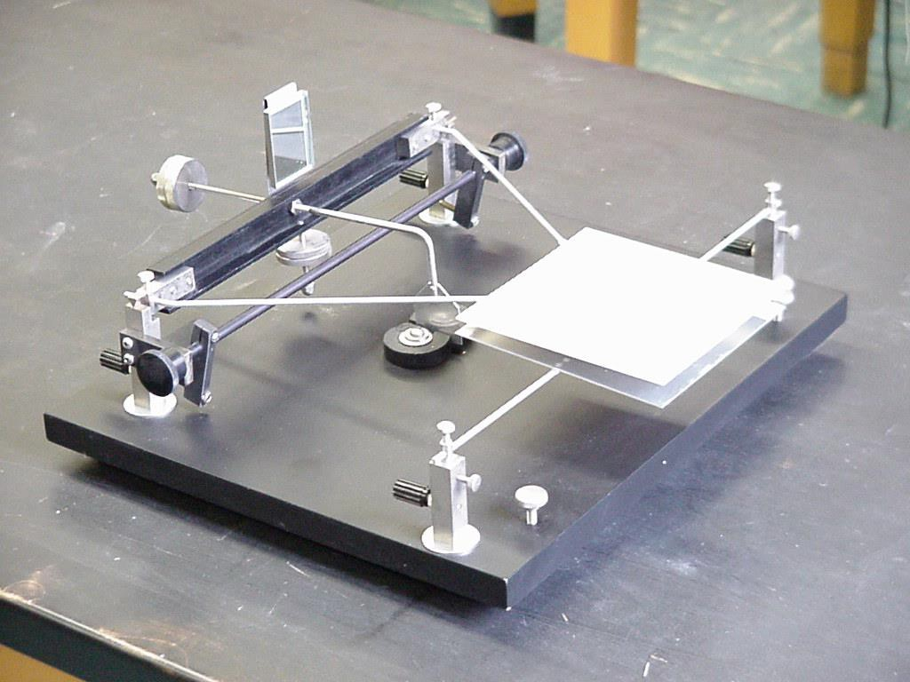

As shown in Fig. 2 below, set up the telescope/scale at one end of the bench, and the apparatus with the plates at the other end. Adjust the screws supporting the baseplate so that it doesn't rock. Remove the guards protecting the knife edge pivot points. Inspect the bearing surfaces to see that they are clean.

The two pivot points on which the cantilevered arm sits are precision-ground knife edges that cannot take rough handling. **ALWAYS USE THE BAIL WHENEVER LIFTING OR LOWERING THE KNIFE EDGES ONTO THEIR BEARING SURFACES**. All positioning adjustments, counterweight adjustments, and mirror adjustments must be done with the bail taking the load, not the knife edges.

Adjust the counterweight so that the upper plate floats 5 - 6 mm above the lower one. Loosen the lower plate mounting setscrews and adjust its position so that it is directly beneath and parallel to the upper plate. Record the plate separation.

You will use the telescope/scale to accurately measure changes in the plate separation. See Appendix 2C for use of the telescope/scale. Align and focus the telescope to get an image of the scale reflected by the mirror at the other end of the bench. A screw adjustment at the back of the mirror allows you to adjust the mirror angle. Set the mirror angle for a view of roughly the middle portion of the scale. Only a small section of the scale will be visible.

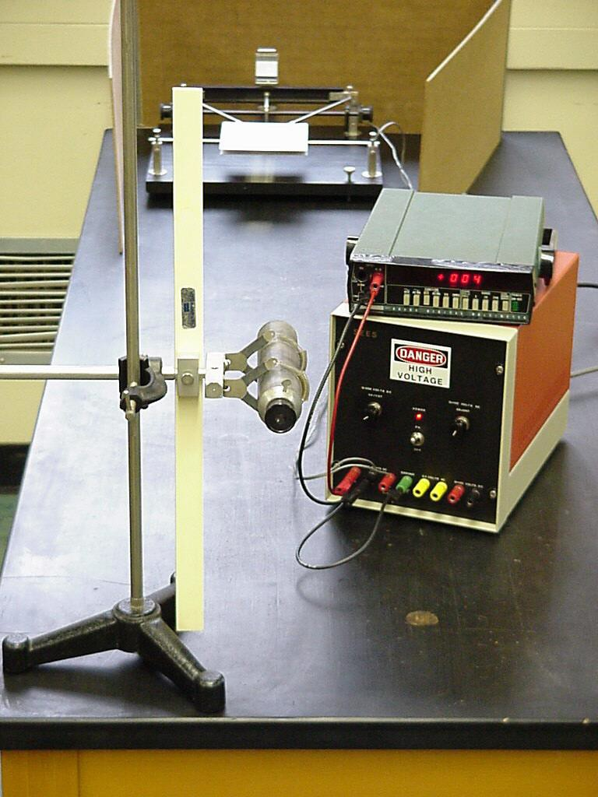

Fig. 2. Experimental setup.

Connect the power supply to the two plates - the upper plate should be grounded as shown below.

0 - 500 V D.C.



low current

+

V voltmeter

upper plate lower plate

ground

Fig. 3. Circuit schematic.

Turn up the voltage, watching when the plates come together. About 300 - 500 volts should be needed. If the plates don't come together, reduce their separation with the counterweight, and try again.

**Experimental Procedure**

Referring to Fig. 4 below, there is only a small range of plate positions where the counterweight force can be balanced by the electrostatic force. Suppose the plate separation is initially ro. For a given ro, there is some maximum plate voltage Vmax, above which the electrostatic force dominates at all plate positions, resulting in the plates coming together. As the voltage is increased toward Vmax, the upper plate moves down until r = 2/3 ro at V=Vmax. For plate positions smaller than 2/3 ro, or V>Vmax, the electrostatic force pulls the plates together. Further explanation of this is provided in Appendix 2B.

1/3 ro

ro

2/3 ro

upper plate, V = 0 volts

upper plate, V = Vmax

lower (fixed plate)

Fig. 4. Illustration of important voltages and plate separations.

Here is how this feature can be used to perform an experiment:

1) The counterweight is adjusted until the plates are parallel with separation ro with no voltage applied between the plates. Measure and record the scale value from the telescope. See Appendix 2C for use of the telescope/scale.

2) Next, the voltage is increased as high as possible without the plates coming together. This plate position and voltage is recorded. At this point the plates are separated by 2/3 ro and voltage V = Vmax. Record the scale value from the telescope (Table 1).

**Table 1**

|  |  |  |  |
| --- | --- | --- | --- |
| **ro (mm)** | **S1 (mm)** | **S2 (mm)** | **Vmax (V)** |
| 4 | 129 | 145 | 206. 4 |
| 4 | 129 | 143 | 204.2 |
| 5 | 105 | 133 | 320 |
| 5 | 105 | 134 | 330 |

**r0: the initial separation between the two plates**

**S1: the recorded value from the scale using telescope at V=0**

**S2: the recorded value from the scale using telescope at V=Vmax**

**Vmax: the maximum applied voltage between the plates without plates coming together**

The difference between positions at zero volts and Vmax is equal to 1/3 ro (see Appendix 2C to convert the telescope/scale readings into actual distances). Take a good deal of care in finding the plate position at Vmax. As you step the voltage higher toward Vmax, the upper plate drops in larger increments, settling to a new position. When the voltage goes too high (above Vmax) the plate will not settle, but drift down, accelerating as it drops. You must estimate at what position this transition occurs (your error estimation for this measurement will likely be larger than the others). Each lab partner should make an attempt at this measurement. Experimental technique influences the measurement of this 2/3 ro position a good deal - make a few attempts.

3) Now you must find what force was acting on the plate at the Vmax position. You will add staples to the

center of the upper plate until it drops to the Vmax position. Each staple has a weight of 32.2mg ± 10%

and you can cut them to different parts to get your desired weight. (Table 2). You might want to make

a graph of position vs. mass to find the mass acting at the Vmax position. The force (F=mg at r=2/3ro is

found rom this data)

Table 2

|  |  |  |  |
| --- | --- | --- | --- |
| ro (mm) | S1 (mm) | S2 (mm) | Number of staples |
| 5 | 10.3 | 13.4 | 4 |
| 4 | 12.6 | 14.5 | 3 + 1/3 |

4) o can be obtained by rearranging Eq. (2) and substituting r = 2/3 ro and V=Vmax :

2

2

 

2*F*  *r* 

*o*

 *o* 

 3 

2

(3)

*AV*max

these measurements have been taken:

- distance from mirror to scale = 138cm (will be used to calculate ro, see Appendix 2C)

- distance from a line between knife edges to rod = 21.5cm (will be used to calculate ro, see Appendix 2C)

- plate dimensions = 13 x 13cm (both plates should have the same area)

- error of benchtop voltmeter for your error analysis=Model is GDM 8245 …. Specs are online.

- error in your scale readings = ± 1 𝑚𝑚

**Answer the following questions in the blank space provided (show all your work and do full**

**uncertainty analysis):**

**• Proper usage of units (1 mark)**

**• Calculate the measurement errors for measured data (1 mark)**

1. Show (derive) a relationship that Vmax occurs at 2/3 ro (Hint: see Eq. 2 of Appendix 2B) (2 marks) why does Vmax occur at 2/3 ro? Is there any physical intuition for this value? (2 marks)

2) Calculate an experimental value for εo with complete error analysis?

(εo: 2 marks and error calculation: 1 mark)

3) Calculate the amount of charge on the plates with complete error analysis.   
(amount of charge: 2 marks, and error calculation: 1 mark)

4) what were your assumption in calculating εo? Write three assumptions of the experiment.   
(2 marks)

An assumption we made in calculating ε0 was that the plates were perfectly parallel to each other. Plates that are not exactly parallel will result in an uneven distribution of charge and field. Another assumption that was made was that each plate was perfectly flat, with no warping, deformation, or bumps present, which can again result in uneven distribution of charge. Finally, we assumed that the electromagnetic field was evenly distributed across the parallel plates, and that no external factors or sources of electromagnetic waves were interfering with the experiment.

5) Reflect on the key components of this lab and its applicability. (3 marks)

The key components of this lab are centered around the effect of the error on the calculation of various values throughout this section of the lab. As seen in question 2, our derived value for ε0 was not accurate to the true value within uncertainty. This can be due to a multitude of factors such as interference from outside electrical devices, the unaccounted-for deformations in the parallel plates, the possibility of uneven field and charge distribution on the plates. As for applications of this lab, parallel plates are commonly used as capacitors. Specifically, they are used in rechargeable batteries, computer circuitry, and other energy storage related applications.

**PART B: Electron Ballistics in an Electric Field**

**Introduction**

The main piece of apparatus in this experiment is the electron beam tube, also known as a cathode ray tube (or CRT) shown in Fig. 1 below.

The CRT is a glass envelope under vacuum. At one end, in the neck, is mounted an electron gun, which sends a focused beam of electrons at high speed toward the phosphor-coated face at the other end. The phosphor coating emits light where struck by the electron beam, with an intensity proportional to beam current. It is a thin coating so that an observer can see the light from the outside.

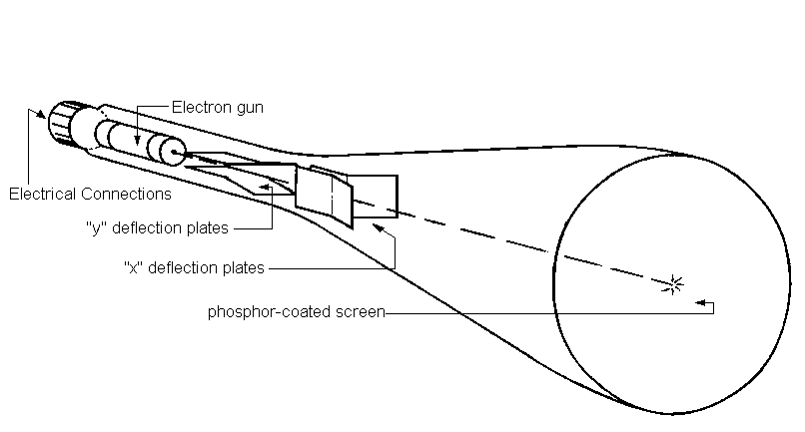Two sets of deflection plates are mounted at the muzzle of the electron gun so that the beam must pass between them (Figure 1). With no voltage across these plates, the beam should hit the face of the CRT in the centre. A voltage applied across the plates creates an electric field, deflecting the beam. Voltages may be applied to the two sets of mutually perpendicular plates to deflect the beam to any spot on the CRT face. In this experiment, we will use only one set of plates to deflect the beam along one axis.

Fig. 1. Schematic of CRT.

**Experimental Setup**

Connect the cathode ray tube to the power supply as in Figure 2. Polarity of the filament is unimportant,

since it is a 60 Hz ac source.

Be sure to connect anode 2 to the power supply ground.

Connect a dc benchtop voltmeter from cathode to anode 2 - this will show the total accelerating voltage. Turn

on the power supply and allow the filament to warm up for a few minutes.

Increase anode 1 voltage in an effort to decrease the spot size to a minimum. Whenever anode 2 is

changed anode 1 may have to be adjusted to refocus the spot.

You may find that the electrons do not hit the face at its center. This may be partly due to earth's magnetic

field. This should not affect your results.

Connect the function generator to the deflecting plates, making sure that the ground of the function

generator is connected to the grounded deflecting plate. The function generator should be set for a square

wave - the frequency is not critical - it can be anywhere between 50 Hz to 5 kHz. Use an oscilloscope to

measure the function generator voltage.

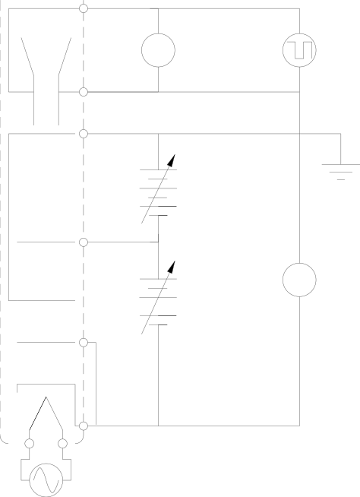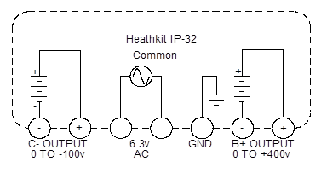10

R

TRUE R.M.S

AC V

9

8

5UPI A2

SQUARE

WAVE

FUNCTION GENERATO

C.R.T. +

0 to +400

VOLTS D.C.

4 - A1

+ DC

0 TO 100

G2

V

VOLTS D.C.

2 - G1

3

CATHODE

6.3 VOLTS A.C. 60 Hz

Fig. 2. Schematic of CRT circuit

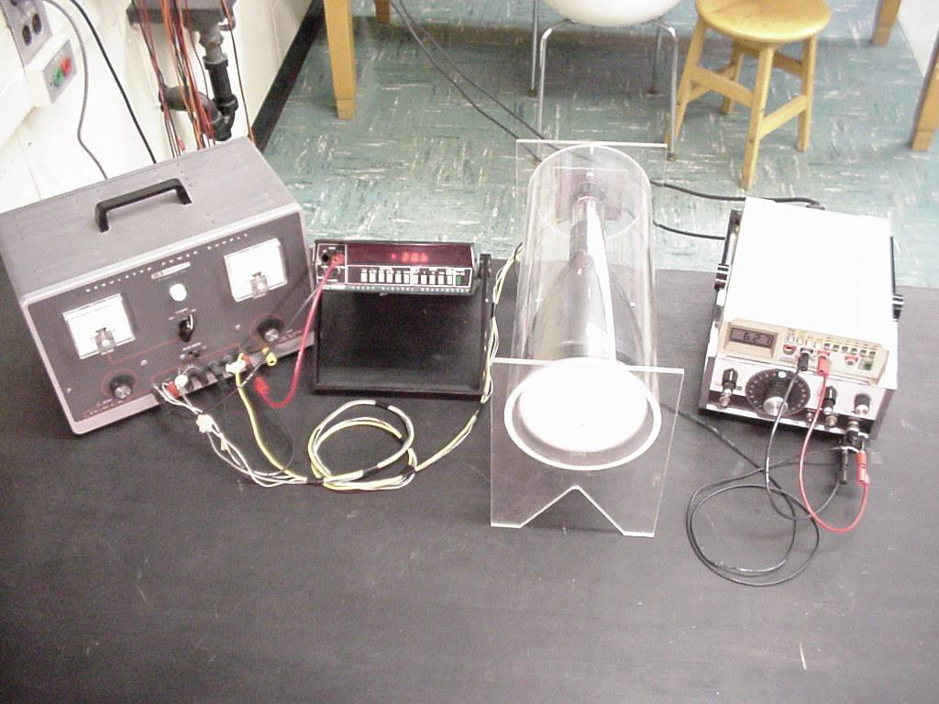

Fig. 3. Picture of experimental setup.

**Experimental Procedure**

Turn up the function generator voltage. The square wave from the function generator moves the electron beam rapidly from one side of the CRT screen to the other, creating two spots visible on the CRT. In this experiment, you will record the distance between these spots for various function generator voltages. Take enough data points to be able to quantify a relationship between the deflection amount on the CRT screen and the deflection plate voltage. The deflection factor is the ratio of the deflection voltage to the deflection amount on the CRT screen (V/cm) and should be a constant at one accelerating voltage.

Set the accelerating voltage to a new setting, re-focusing the spot. Record a set of new spot deflections and voltages.

Do a third set of measurements at yet another accelerating voltage.

Table 3

|  |  |  |  |  |  |  |  |
| --- | --- | --- | --- | --- | --- | --- | --- |
| Va =150 V | |  | Va =250 V | |  | Va =350 V | |
| Vd (V) | d (mm) | Vd(V) | d (mm) | Vd (V) | d (mm) |
| 1.44 | 9 | 1.44 | 6 | 1.44 | 5 |
| 2.28 | 13 | 1.76 | 8 | 2.32 | 7 |
| 3.56 | 17 | 2.36 | 10 | 3.28 | 9 |
| 5.12 | 23 | 3.88 | 12 | 5.12 | 11 |
| 6.40 | 28 | 4.96 | 15 | 6.08 | 13 |
| 7.72 | 33 | 6.60 | 19 | 6.84 | 14 |
| 7.92 | 34 | 7.32 | 21 | 7.84 | 17 |

Va: accelerating voltage

Vd: defelection voltage

d: the distance between for two spots

A good deflection system should be linear: deflection of the beam should be proportional to deflection voltage.

**Answer the following questions in the blank space provided (show all your work and do full uncertainty analysis):**

• **Proper usage of units (1 mark)**

• **Calculate the measurement errors for measured data (1 mark)**

1) Using the parallel plate approximation (see Appendix 2E), derive a relationship that relates the amount of electron beam deflection on the CRT face to the deflection voltage (VD), accelerating voltage (VA) and the CRT’s physical dimensions. (6 marks)

2) Compare the theoretical amount of deflection with the measured amount of deflection for a few data points from your experiment. Include complete error analysis for the

experimental data. (Comparison: 1 mark; Error Calc: 1 mark)

Sample Calculations:

|  |  |  |
| --- | --- | --- |
| 215 V | | |
|  | d (theoretical) (cm) | d (measured) (cm) |
| 5.6 V | $2.18±0.2$ | 7 |

|  |  |  |
| --- | --- | --- |
| V | | |
| $$V_{d}$$ | d (theoretical) (cm) | d (measured) (cm) |
| 5.6 V | $$1.49±0.1$$ | 23 |

|  |  |  |
| --- | --- | --- |
| V | | |
| $$V_{d}$$ | d (theoretical) (cm) | d (measured) (cm) |
| 5.6 V |  | 21 |

3) Provide four reasons as to why the theoretical deflection values differed from your experimental deflection values. (4 marks)

One possible reason is the angled parallel plates, possibly affecting the path of the beam and yielding a deflection that was different from the one calculated theoretically. This is because the theoretical calculation was considering two, flat, parallel plates and not two angular plates.

Another possible reason is the possible dents, deformation, and flaws in the surfaces of the plates that went unaccounted for, and in addition that the electromagnetic field is evenly distributed. These would cause changes in charge distribution across the surface of the plates. We are also assuming that there are no sources of electromagnetic interference which can be disturbing the experiment and possibly changing results. These changes can be caused by almost any electrical device such as lights, radios, microwaves. Finally, there is always the consideration of human error than needs to be made when discussing the results of an experiment. Measuring with a ruler by eye can lead to human error, and it is cause for estimation. Another common estimation is during the measurement of the beam on the phosphor coated screen, when the beam is thicker than the smallest division on the ruler and we have to estimate where to measure from.

4) Derive a relationship for the deflection factor that depends on the accelerating voltage (VA) and the CRT’s physical dimensions. Calculate the deflection factor (volts/meter) for each accelerating voltage chosen during the experiment. Include complete error analysis. (Derivation: 1 mark; Deflection calculation: 1 mark; Error Calc: 1 mark)

Sample Calculations

|  |  |
| --- | --- |
|  | δ (V/m) |
| 215 V | (~7%) |

|  |  |
| --- | --- |
|  | δ (V/m) |
| 315 V |  |

|  |  |
| --- | --- |
|  | δ (V/m) |
| 380 V | (~7%) |

5) Plot the deflection factor as a function of accelerating voltage. Include error bars in the plot. (2 marks; -0.5 for missing either or x or y error bar)

**there are error bars in the x, they are just very small (1%)

6) Is the deflection of the electron beam proportional to the deflection voltage, as it should be for a good deflection system? What relationship do you observe between the accelerating voltage and the deflection factor? (2 marks)

From the equation derived in question 1:

As can be observed, D’ (deflection of the electron beam) is linearly proportional to deflection voltage, Vd.

In addition, observing the graph from question 5 and the equation from question 4, it can be observed that the acceleration voltage, Va, and the deflection factor, δ, are also linearly proportional.

7) Reflect on the key components of this lab and its applicability. (3 marks)

The key components of this lab concerned the relationship between the input voltages Vd and Va, and their effect on the deflection of the beam. Deflection was found to be linearly proportional to Vd as expected, however, it is also inversely proportional to Va. On the other hand, in terms of the deflection factor, that was found to be linearly proportional to Vd. Another key component of this lab was the uncertainty analysis. There were many factors which may have caused our results to differ from the measured values, such as the angled nature of the parallel plates’ effect on the trajectory of the electron beam, and how this was not accounted for in the derivation for D’. Instead, D’ focused on the effect of an electron beam through a conventional parallel plate capacitor. Another major cause of error was unaccounted for interference during the experiment and flaws in the surface of the plates. In terms of applications, deflection of electron beams is commonly used in mass spectrometry, where the radius of the electron path can be used to calculate the mass of the object in question. In addition, electron beams were used in CRT (cathode ray tube) television sets.

Sources:

ushendra's engineering tutorials. (2020, September 10). *Electrostatic deflection | CRO | deflection sensitivity* [video]. YouTube. <https://www.youtube.com/watch?v=mYKP6B4hTHI>

**APPENDIX 2A: Force Between Two Charged Parallel Plates**

From Figure 1 below and Gauss' Law:

⇩ *En*

*ds*  *Q*



*o*

The enclosed charge (in area *s*) is Q =  *s* and area  ds = 2s, therefore

*E*  

2 *o*

For two parallel plates of opposite charge, the field between the plates will be:

*E*  

2 *o*

   

2 *o*  *o*

Now the force on one plate = (charge on one plate) x (electric field on the other plate):

*F*  *EQ*  

2

*A*   *A*

(1)

2 *o*

2 *o*

With distance *r* between parallel plates, the voltage at any point between the plates is:

0 *r*

So,

*V*   *E*  *dx* 

*r o*



⬧  *V*  *o*

*r*

(2)

Combining (1) with (2):

*V* 2 *A*

*F*   *o*

2*r* 2

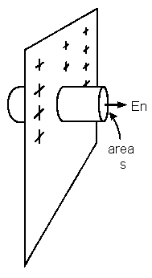

Fig. 1. Electric field En on a single, infinite plate.

**APPENDIX 2B: Determining** **o**

Two plates are charged to a known voltage, generating an attractive force between them. One plate is fixed, while the other is suspended above on a cantilevered arm. The electrostatic force from the charged plates is opposed by gravity acting on a counterweight. For small motions of the upper plate, the opposing counterweight force is linear. This force can be calibrated by placing small known weights at the centre of the upper plate, noting the deflection with the telescope/scale.

A simple experimental procedure could go like this:

•  A small known weight placed at the centre of the upper plate causes it to drop down. The position is noted with the telescope/scale (position, p1) .

•  With the weight removed, a voltage is applied between the plates, adjusted to give the same plate position (p1).

•  The plate separation is found by pushing the plates together, and noting the new position with the telescope/scale (p2).



The permittivity is then found from:

 *AV* 2

*mg*   *o*

2

(1)

2( *p*1

− *p*2 )

*g* = 9.807 Newtons/kg, the gravitational constant

*m* = mass of the small weight (kilograms).

*A* = plate area, square meters.

*V* = voltage applied to plates, volts.

*p1 - p2* = plate separation, meters.

There is a difficulty with the apparatus using this simple method, resulting in a systematic error. The error arises because of the cantilevered arm motion of the upper plate. The plates can only be parallel at one position, since the upper plate moves in the arc of a large circle. If the plates are parallel at p1, then p2 will be in error.

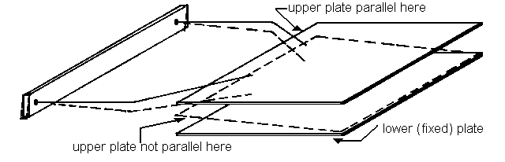

**A Better Procedure**

Apart from modifying the apparatus to maintain parallel plates at all plate positions, a better experiment can be performed requiring the plates to be parallel over a smaller distance. Let us take another look at the motion of the upper plate, as voltage is changed. Let the initial plate separation (when V = 0 volts) be r0. The force due to the counterweight is a linear function of displacement:

*F*  *kd*  *k* (*ro*  *r*)

(2)

Force *F* is in an upward direction for a downward displacement (r < r0).

*k* is a constant, fixed by the counterweight position.

*(r0 - r)* is the displacement from rest position, r0.

With a voltage applied between the plates, the upper plate will move down until the electrostatic force is equal to the force described above:

 *AV* 2

*k* (*ro*  *r*)   *o*

2*r* 2

(3)

There is only a small range of plate positions where the counterweight force can be balanced by the electrostatic force. For a given ro, there is some voltage Vmax, above which the electrostatic force dominates at all plate positions, resulting in the plates coming together. As the voltage is increased toward Vmax, the upper plate moves down until at Vmax, r = 2/3 ro. For plate positions below 2/3 ro, the electrostatic force of Vmax pulls the plates together.

Here is how this feature can be used to perform a better experiment:

1/3 ro

ro

2/3 ro

upper plate, V = 0 volts

upper plate, V = Vmax

lower (fixed plate)

1) The counterweight is adjusted until the plates are parallel with separation ro with no voltage applied between the plates.

2) Next, the voltage is increased as high as possible without the plates coming together.

3) The plate position and voltage is recorded just before the plates come together. At this point r = 2/3 ro

and voltage V = Vmax.

4) The force at the latter position is determined by adding various masses (m) to the upper plate (with no voltage) to calibrate the force as a function of plate position. The force F = mg at position r = 2/3 ro is

found from this data.

Then

2

 

2

2*F*  *r* 

3 *o*





 

(4)

*o*

2

*AV*max

**APPENDIX 2C: Measuring Plate Separation**

The measuring system consists of a vertical scale, mounted beside a telescope (with crosshairs), and a

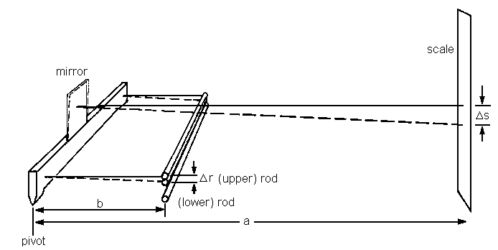mirror that tilts with arm motion. 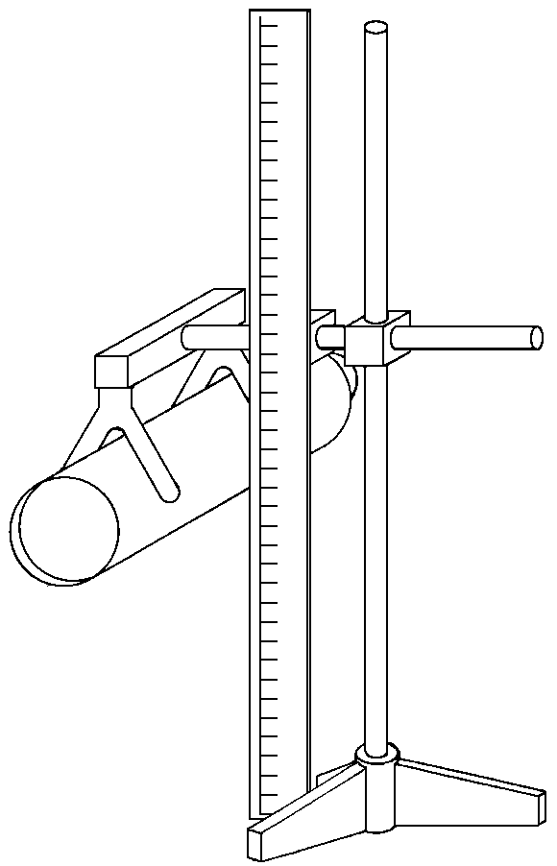

A small motion about the pivots causes the unknown displacement r to translate linearly to the scale as

s.

2a = s a is the distance from mirror to scale b r b is the distance from pivot to rod.

r = s b In our experiment a is about 1.5 meter, b is about 0.2 meter

2a

The scale is calibrated in 1mm increments. You should try to interpolate this scale as far as possible to improve accuracy. Taking readings from this scale to ± 0.2 mm requires excellent skill. An error of ± 0.2 mm (2 X 10-4 m) on the scale translates to an error in r of:

2*x*104 *x*

0.2

(2)1.5

 0.133*x*104  13*m*.

Assumptions made:

- mirror surface is parallel to scale, normal to the arm.

- displacement r is small compared with arm length, b.

- motion about the pivot is a small fraction of a radian.

**APPENDIX 2D: The Electron Gun**

A sketch of the electron gun and deflection system for the 5UPI cathode ray tube is shown in Figure 2. The cathode which is electrically connected to one of the pins at the tube base, emits a cloud of electrons when heated by the filament (a resistive element whose ends are also brought to two pins at the tube base). It is the filament and cathode which you can see glowing when the tube is operating.

A small metal cup, with a tiny hole pointing at the CRT face confines the electron cloud, allowing a measured flow of electrons to be accelerated out the hole by the following electrodes. It is also connected to one of the pins at the tube base. This is called the "control grid", or "grid l" (G1). A negative voltage (with respect to the cathode) on this grid will reduce the beam current, resulting in a less intense spot on the CRT face.

Next to the control grid is a cylinder which is also brought to a pin at the tube base. It is called "grid 2" or G2. Operated at a high positive potential (with respect to the cathode), it accelerates any electrons coming out the hole of grid 1.

Next is "Anode 1", another cylinder known as the focusing anode, also brought to a pin at the tube base. A voltage on this element between the potentials of cathode and grid 2, forms an "electron lens". It focuses the beam at the C.R.T. face.

Next is "Anode 2", another cylinder internally connected the grid 2. Anode 2 is part of the electron lens, and also serves to collect electrons rebounding from the C.R.T. phosphor. For this purpose it is electrically connected to the coating on the inside of the glass envelope. Electrons passing through anode

2 travel through both sets of deflection plates to the C.R.T. face at constant velocity, determined by the cathode to anode 2 potential difference.



Fig. 1. Schematic of CRT.

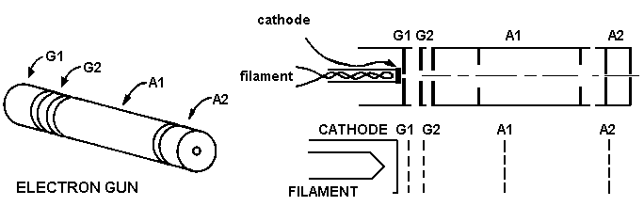

Fig. 2. Schematic of electron gun.

**Power Supply Connections**

In the preceding description of the electron gun, electrode voltages were described relative to the cathode, where electrons start their journey. In our experiment, it is required that the deflecting plates be at ground potential, since they will be connected to the function generator (whose output voltage is near ground). To simplify the analysis, the deflecting plates should generate an electric field that changes the electron direction without changing its velocity. To meet this requirement, the deflection plates must be close to the potential of Anode 2. With both Anode 2 and one of the deflection plates grounded, the other deflection plate is driven by the function generator. Anode 1 must then be at a negative potential, and the cathode at a further negative potential with respect to the grounded Anode 2.

Since we will use power supply voltages lower than those normally used for the 5UP1 CRT, the beam current will be low enough for the beam current limiting action of grid 1 not to be required. Grid 1 can be left unconnected (the electron cloud will bring it to the same potential as the cathode) , or shorted to the cathode. The power supply requirements for the electron gun are:

6.3 V rms (or dc) 0.6 amps ........filament

300 V- 500 V dc ........anode 2 w.r.t. cathode

300 V – 500 V dc …….grid 2 w.r.t. cathode

100 V - 150V dc .........anode 1 w.r.t. cathode

Anode 2 and Grid 2 are internally connected – one power source supplies both. Voltages on anode 2 and anode 1 are variable, so that the deflection can be studied with different electron velocities. You should measure and record the *total* accelerating dc voltage with the analog multimeter – this is the voltage difference between cathode and Anode 2.

With the digital ac voltmeter, record the rms square-wave voltage between the deflecting plates.

**APPENDIX 2E: Deflection Plate Approximation**

The deflection plates in the 5UP1 cathode ray tube are not parallel for their entire length, but flared outward at one end. We will make an approximation, treating these plates as parallel for their entire surface. Figure 3 shows the plate dimensions.

2.62

± .01

0.913

± .005

0.245 ± .005

1.0 ±.05

0.785

± .007

❑

23.7 ± .2 to C.R.T. face

0.254 ± .005

1.0 ± .05 .913cos 

Deflection plate dimensions

in cm.

PARALLEL PLATE APPROXIMATION

Fig. 3. Schematic of the deflection plates.

Uncertainties:

Weight of one full staple: 32.2 mg ± 10 %

Ruler: ½ the smallest division (smallest division=1mm)

Voltmeter: 0.2% of reading + 9 digits

Oscilloscope: ½ the smallest division (smallest division=1V)

**Total Marks : 39 marks**